**An Analysis of Career Trajectories:**

**Salary & Experience Across Global Industries**

**1.Context**

This project analyzes salary trends across different industries using real-world salary survey data. It involves data cleaning, SQL queries, and Excel dashboard creation to uncover insights about salaries, job roles, experience, education, and gender distribution.

**2.Objective**

The goal is to identify salary patterns, compare job titles, industries, experience levels, and gender-based salary distribution. This helps in understanding which factors influence earnings and assists professionals in making informed career decisions.

**3.Scope**

* Data cleaning and processing
* Storing the dataset in MySQL
* Running SQL queries for key insights
* Exporting data to Excel and creating pivot tables
* Designing a visual dashboard to present salary trends

**4.Audience:**

* Job seekers & employees – To understand salary trends and career growth potential
* HR & recruiters – To benchmark salaries for different roles and experience levels
* Business leaders & policymakers – To analyze workforce trends and gender pay gaps
* Data analysts & students – To practice SQL, data visualization, and dashboard creation

**5.Techniques Used in the Project**

1. **Data Cleaning & Preprocessing** – Handling missing values, correcting inconsistencies (e.g., country names, currency formats), and structuring data for analysis.
2. **SQL Queries** – Extracting insights from a MySQL database using aggregation, filtering, and joins to analyze salary distributions, job roles, and industries.
3. **Data Transformation** – Using Power Query in Excel to manipulate and format data for visualization.
4. **PivotTables & PivotCharts** – Summarizing key insights using interactive tables and visual elements in Excel.
5. **Dashboard Creation** – Designing an **interactive salary trends dashboard** with charts, slicers, and KPIs for easy interpretation of insights.

**6. Dataset Overview**

**1. Attributes of the Dataset**

The dataset includes various factors influencing salary trends across industries:

* **Age Range** – Distribution of employees across different age groups.
* **Industry** – Various sectors such as IT, Healthcare, Finance, etc.
* **Job Title** – Different roles like Software Engineer, Project Manager, Data Analyst, etc.
* **Salary** – Compensation details, including currency adjustments.
* **Experience** – Number of years in the industry.
* **Education Level** – Degree qualifications like Bachelor's, Master's, PhD, etc.
* **Gender** – Distribution of salary trends across different gender identities.
* **Country** – Geographic location of employees.

**2. Data Source**

* The dataset was compiled from global salary surveys and industry reports.
* It includes salary information from various countries, ensuring a diverse dataset.
* Currency conversions were applied to standardize salary values.

**7. Data Cleaning**

**1.** **Data Preprocessing**

* Checked for **blank values** and replaced them with appropriate placeholders.
* Formatted data with **correct data types** (e.g., currency, dates, numbers).
* Used **Power Query in Excel** to fix spelling errors and inconsistencies.
* **Removed duplicates (nearly 200 entries) to ensure data integrity.**

**2.** **Handling Currency Variations**

* The dataset contained salaries in **multiple currencies**, so all values were converted into **USD** for uniform analysis.

**3.** **Outlier Detection & Removal**

* **Age-related inconsistencies**: Identified unrealistic age values where 18-24-year-olds had 41+ years of experience and removed them.
* **Experience-based filtering**: Older, more experienced individuals had **invalid information**, so they were treated as outliers and removed.
* **Salary outliers**:
  + Salaries **below $100** were unrealistic and removed.
  + Salaries **above 10 crores** were cross-checked with job titles, if they didn't justify the pay, they were removed as outliers.

**4.** **Data Structuring & Optimization**

* **Freeze Panes in Excel** to keep key columns visible during analysis.
* Standardized job titles, industries, and education levels for **better classification**.

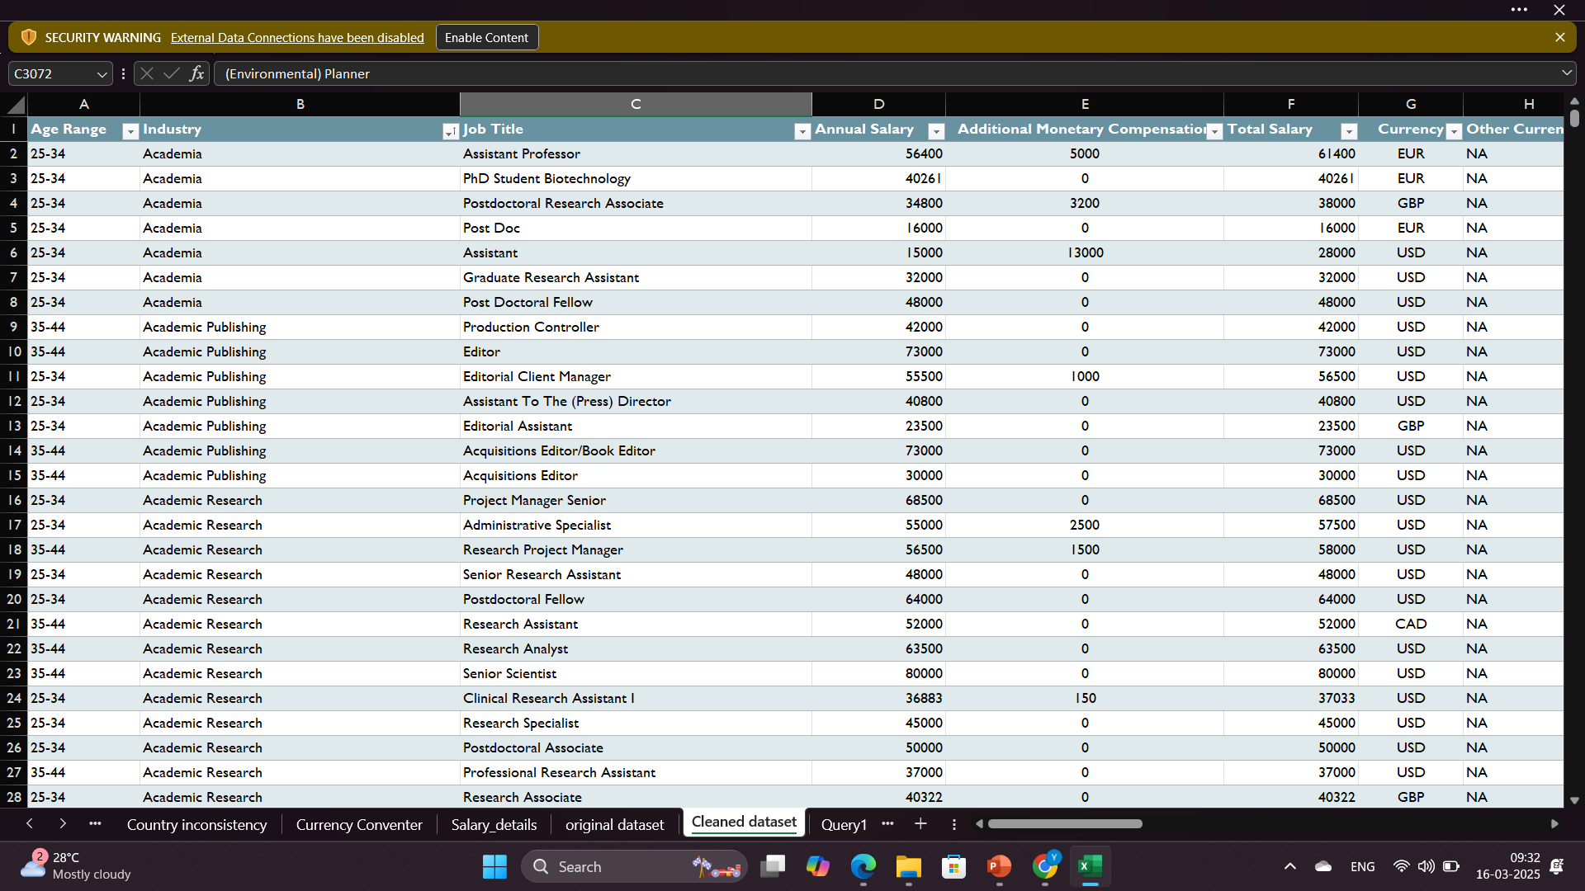

**8. Importing Data To MySQL**

**1️.Creating Database & Table**

* Created a database (Salary_Analysis).
* Designed a structured table with relevant columns (Salary, Industry, Experience, etc.).

**2️. Uploading Data using Table Wizard**

* Used **MySQL Workbench Table Wizard** for easy data import.
* Ensured correct data mapping and field types.

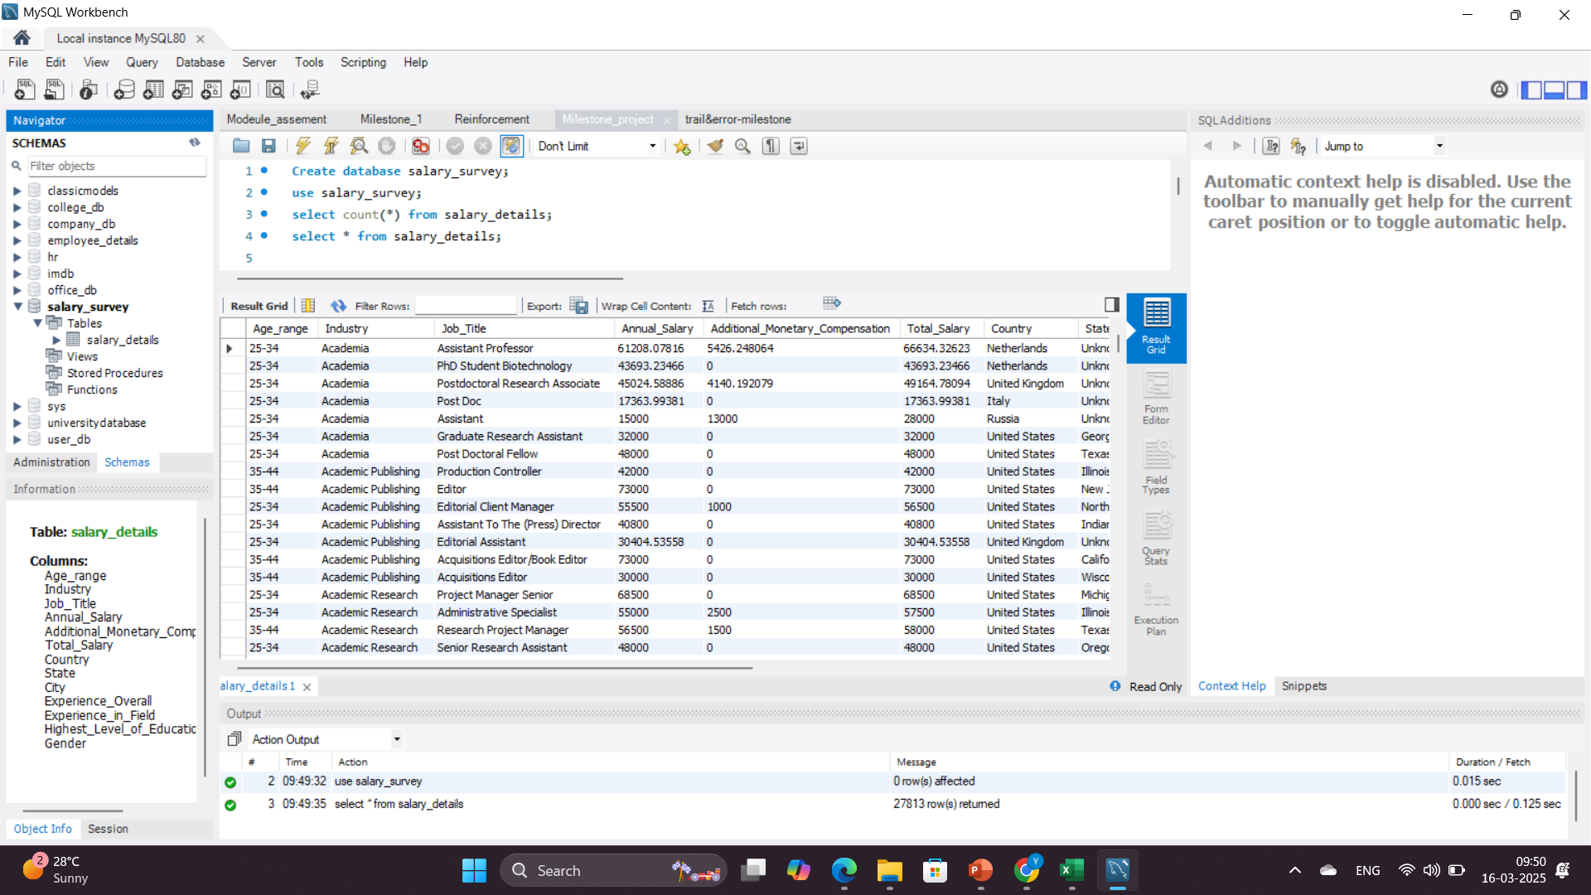

**9. Queries**

**1. Average Salary by Industry and Gender**

**Explanation:** This query calculates the average salary for each industry and gender using AVG(). Grouping by Industry and Gender ensures distinct calculations, while ROUND() formats values to two decimal places. The results are sorted in descending order to highlight the highest salaries.

**Rationale:** This analysis identifies high-paying industries and highlights salary differences

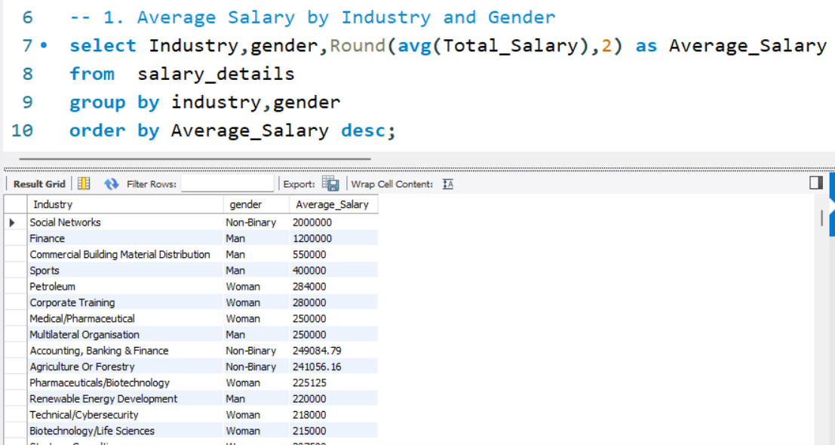

**2. Total Salary Compensation by Job Title**

**Explanation**

This query calculates the total salary paid for each job title. It:

* Adds up (SUM) all salaries for each job.
* Groups results by job_title to get total earnings per role.
* Rounds values for clarity.
* Sorts the data in descending order to highlight top-paying roles.

**Rationale:** This analysis helps in understanding salary distribution across different job roles and provides valuable insights for both organizations and job seekers.

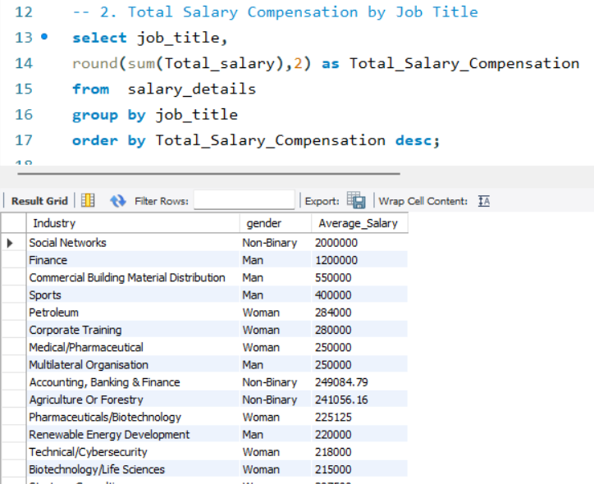

**3. Salary Distribution by Education Level**

**Explanation**

This query analyzes salary distribution based on education level. It calculates:

* Average Salary: The mean salary for each education level.
* Minimum Salary: The lowest salary recorded.
* Maximum Salary: The highest salary recorded.

The results are grouped by education level and sorted accordingly.

**Rationale:** This analysis helps understand how education impacts salary. Higher education generally leads to higher earnings, but exceptions exist.

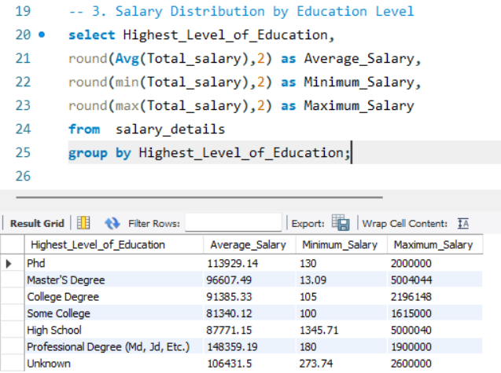

**4. Number of Employees by Industry and Years of Experience**

**Explanation**

* The query counts the number of employees in different industries based on years of experience.
* It groups by Experience_in_Field and Industry, then sorts in descending order.

**Rationale**

* Helps identify industries with high demand for experienced professionals.
* Assists job seekers in understanding which industries have more employees at different experience levels.

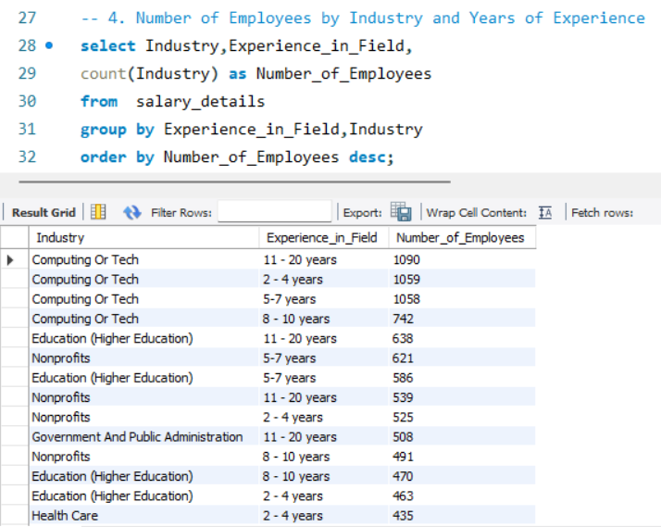

**5. Median Salary by Age Range and Gender**

**Explanation**

* Assigns row numbers and total count for salaries within each age and gender group.
* Selects the middle salary using the median formula.
* Groups by age_range and gender, rounding results to two decimal places.
* Orders by highest median salary.

**Rationale**

* Provides accurate median salaries without extreme value distortions.
* Helps employers and job seekers understand pay trends by age and gender.

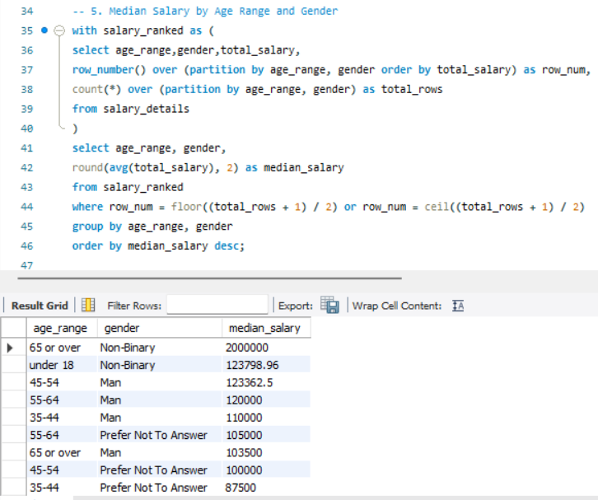

**6. Job Titles with the Highest Salary in Each Country**

**Explanation**

* The query first calculates the highest salary for each job title in different countries.
* The rank() function assigns a ranking to each job title within a country based on salary in descending order.
* The second part of the query selects only the job title with the highest salary per country (rank_by_country = 1).
* The results are ordered by highest salary in descending order.

**Rationale**

* Helps identify the highest-paying job roles in different countries.
* Provides insights into salary distribution across industries and locations.

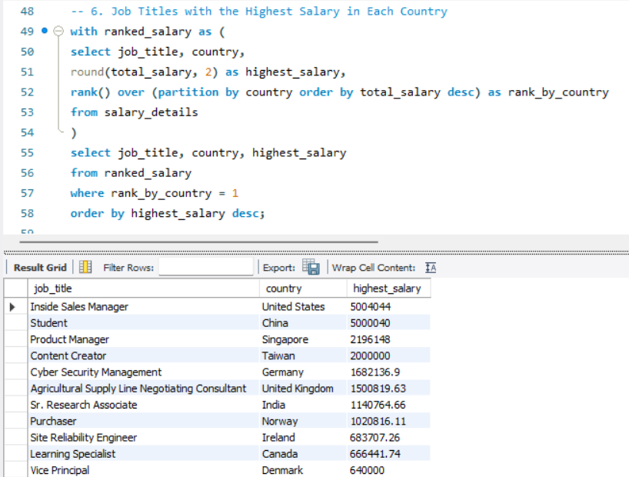

**7. Average Salary by City and Industry**

**Explanation**

* The SQL query calculates the average salary for each industry in different cities.
* It groups by Industry and City, calculates the average salary, and orders results from highest to lowest.

**Rationale**

* Helps identify which industries and cities offer the best salaries.
* Useful for professionals choosing a job location and companies setting competitive salaries.

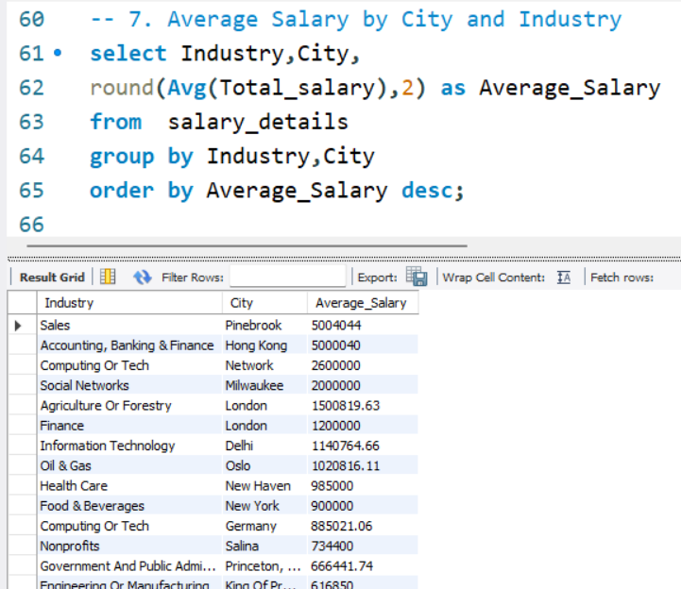

**8. Percentage of Employees with Additional Monetary Compensation by Gender**

**Explanation**

The query calculates the percentage of employees in each gender who received additional compensation.

* COUNT(CASE WHEN Additional_Monetary_Compensation > 0 THEN 1 END) counts only those who received compensation.
* COUNT(*) counts total employees per gender.
* (Count of compensated employees * 100) / Total employees gives the percentage.
* ROUND(value, 2) ensures two decimal places.
* GROUP BY gender calculates separately for each gender.

**Rationale**

This method shows how likely employees of each gender are to receive additional compensation, with percentages calculated independently.

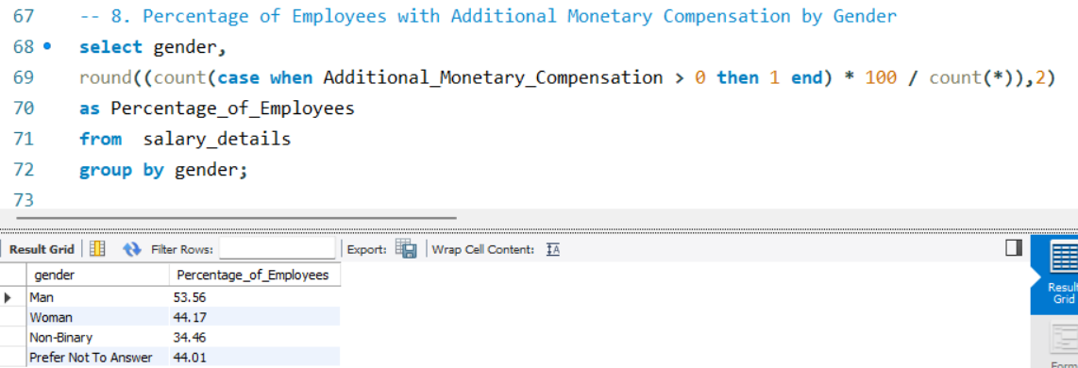

**Explanation**

The query calculates the percentage of employees within each gender among those who received additional compensation.

* COUNT(*) counts employees per gender with compensation.
* The denominator is the total employees with compensation.
* (COUNT(*) * 100.0) / Total gives the percentage.
* ROUND(Value, 2) formats it to two decimal places.
* GROUP BY gender organizes data by gender.

**Rationale**

This method shows how compensation is distributed among recipients, ensuring percentages sum to 100%.

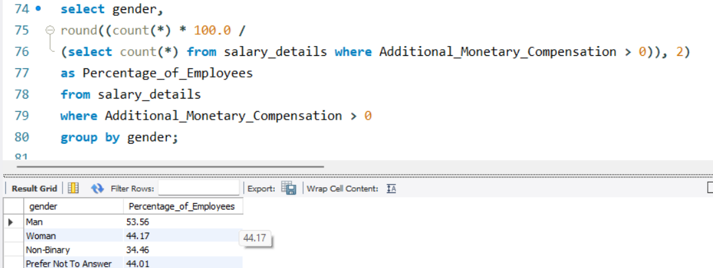

**9. Total Compensation by Job Title and Years of Experience**

**Explanation**

The SQL query retrieves total salary compensation by job title and years of experience. It does this by

* Grouping data by Job_Title and Experience_in_Field.
* Summing up Total_Salary for each group.
* Rounding the result to two decimal places.
* Sorting the results in descending order to show the highest total salary first.

**Rationale**

* Identify which roles have the highest total salary payouts.
* Compare compensation across different experience levels within the same job title.
* Understand workforce salary trends for better budget planning.

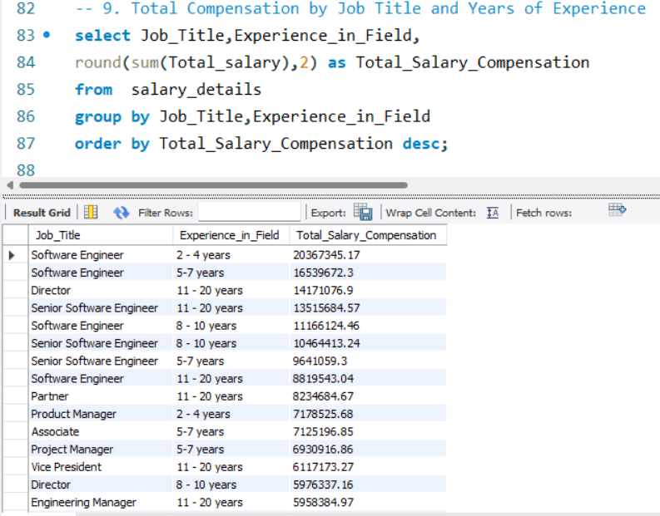

**10. Average Salary by Industry, Gender, and Education Level**

**Explanation**

* The SQL query calculates the average salary for employees based on industry, gender, and education level.
* It uses AVG(Total_salary) to compute the average salary per group.
* ROUND(...,2) ensures the result is formatted with two decimal places.
* The GROUP BY groups data by industry, gender, and education level.
* ORDER BY Average_Salary DESC ranks the industries with the highest average salaries first.

**Rationale**

* Helps understand how salary varies based on industry, gender, and education.
* Highlights which industries pay the highest salaries.
* Identifies whether education level affects salary.
* Useful for companies and employees to compare salary trends.

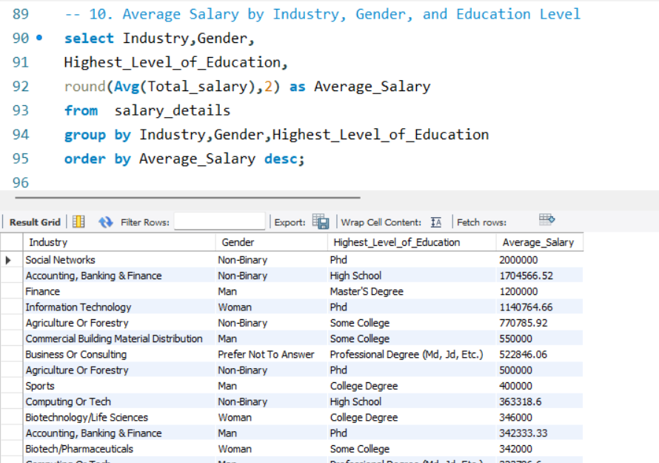

**10. Data Export To Excel**

**1. Exporting Data**

The query results are extracted from the MySQL database and exported as a CSV file for further processing.

**2. Data Formatting in Excel**

The exported data undergoes structuring, and proper formatting in Excel.

**3. Data Analysis Using Pivot Tables & Charts**

Key insights are derived by summarizing the data through pivot tables and visualizations, allowing for better trend analysis.

**4. Extracting Key Findings**

Trends, patterns, and crucial insights are identified from the analysis to support informed decision-making and strategic planning.

**11. Analysis Of Queries**

**1. Average Salary by Industry and Gender**

* **Highest overall salary:** Social Networks industry.
* **For men:** Finance, Utilities, and Telecommunications offer the highest salaries (around $121K USD).
* **For women:** Petroleum, Corporate Training, and Medical/Pharmaceutical industries provide the highest salaries (around $280K USD).

**Gender-Based Salary Comparison:**

* The **male-to-female salary ratio** varies across industries, showing wage disparities.
* **Men earn more** in Finance, Utilities, and Telecommunications due to traditional industry dominance.
* **Women earn more** in Medical/Pharmaceutical and Petroleum, likely due to specialized roles.
* These insights help in addressing gender pay gaps and improving career opportunities.

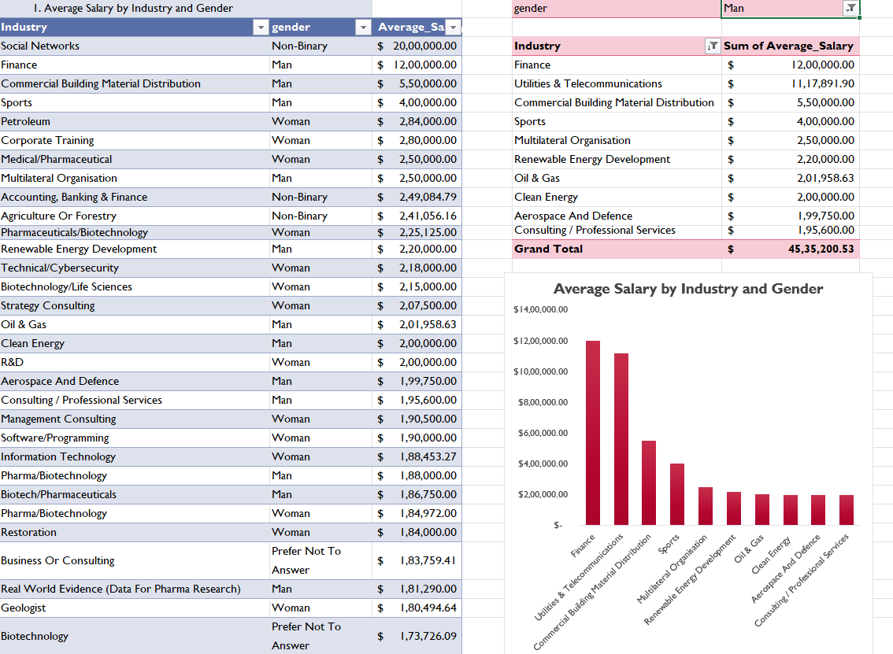

**2. Total Salary Compensation by Job Title**

**Insights**

* Software Engineers earn the highest total salary, showing strong demand for tech jobs.
* Senior Software Engineers, Directors, and Project Managers also receive high salaries, emphasizing leadership and expertise.
* Tech and management roles offer the best earnings.
* 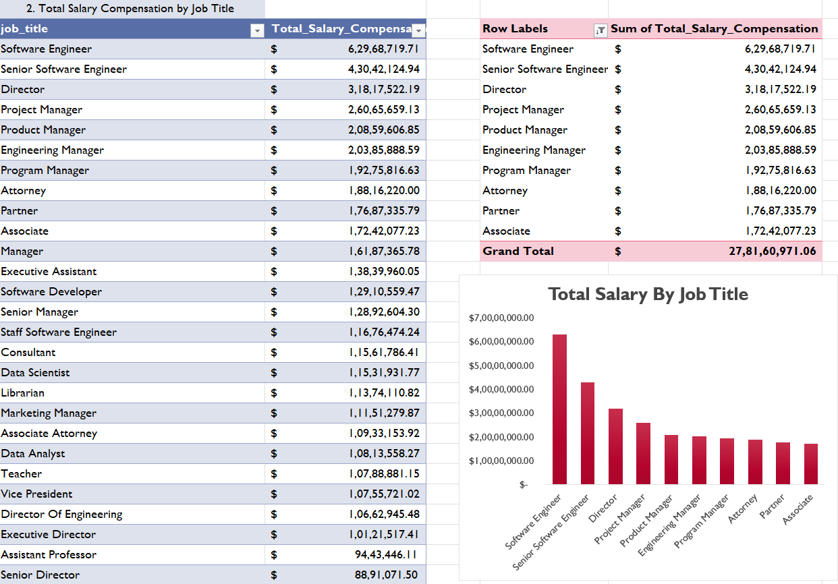Companies can use this data to set competitive salaries, and job seekers can target high-paying careers.

**3. Salary Distribution by Education Level**

**Insights**

1. **Highest Average Salary**:

* Professional Degrees (MD, JD, etc.) have the highest average salary (~$148K).
* PhD holders also earn well (~$113K).

1. **Minimum Salary Trends**:

* Surprisingly, even Master’s Degree holders have a minimum salary as low as $13.09, showing entry-level or unpaid roles.
* High school graduates have a higher minimum salary (~$1,345), possibly due to wage floors.

1. **Maximum Salary Trends**:

* The highest maximum salary ($50M) is found among Master’s and High School graduates, indicating some high-paying executive or business roles.
* PhD and Professional Degree holders still reach $20M+, proving strong earning potential.

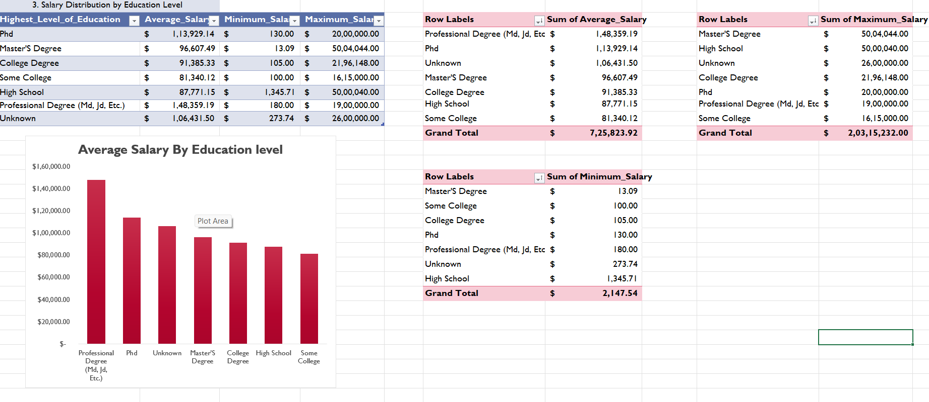Higher education generally leads to better salaries, but some high-paying roles do not require advanced degrees.

**4. Number of Employees by Industry and Years of Experience**

**Insights:**

* Computing/Tech industry has the highest number of employees across different experience levels, with over 1,000 employees in each category.
* Higher Education and Nonprofits have a significant workforce in the 5-7 years and 11-20 years experience range.
* Law and Marketing industries have fewer employees, indicating either lower demand or more specialized roles.
* Government and Public Administration also employs many professionals, particularly in mid-career roles (5-10 years).

**Key Findings**

* Higher education levels lead to higher salaries, but minimum salaries vary widely.
* Tech and Education sectors employ the most professionals, especially in mid-career roles.
* These insights help job seekers, employers, and policymakers make informed decisions.

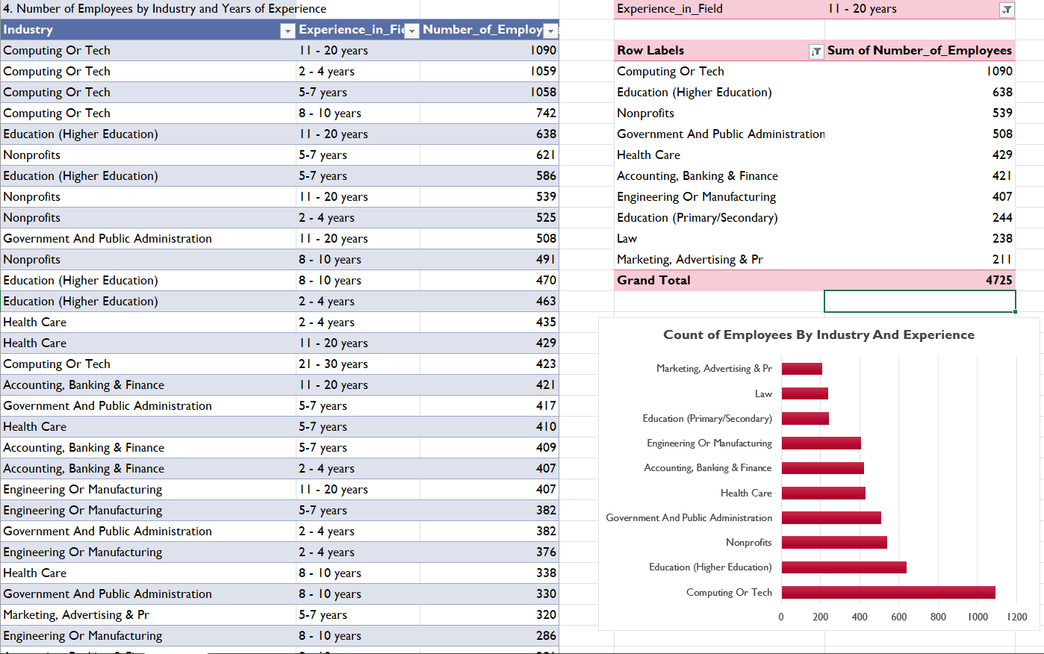

**5. Median Salary by Age Range and Gender**

**Insights**

1. **Highest Salaries**:
   * Non-Binary (65+) has the highest median salary ($2,000,000), likely due to high-ranking senior roles.
   * Young Non-Binary (under 18) also shows a high median salary ($123,798.96), possibly due to niche skills.
2. **Gender Trends:**
   * Men generally earn higher median salaries than other groups in several age ranges.
   * “Prefer Not to Answer” category shows strong earnings, indicating that some high earners opt out of gender disclosure.
3. **Age Trends:**
   * Salaries increase with age and experience, with professionals in the 45-64 age range earning the most.
   * Younger employees (18-24) have significantly lower median salaries, reflecting entry-level roles.
4. **Diversity in Salary Distribution:**
   * Some gender categories show high salary variance, possibly due to limited data or diverse job roles.
   * Wide minimum salary ranges indicate the presence of both entry-level and senior positions within the same categories.

**Key Findings**

* Experience strongly influences salary growth across all genders.
* Gender-based pay differences exist, with men generally earning more.
* Employers can use these insights to promote fair pay practices, while job seekers can better understand salary expectations by age and gender.

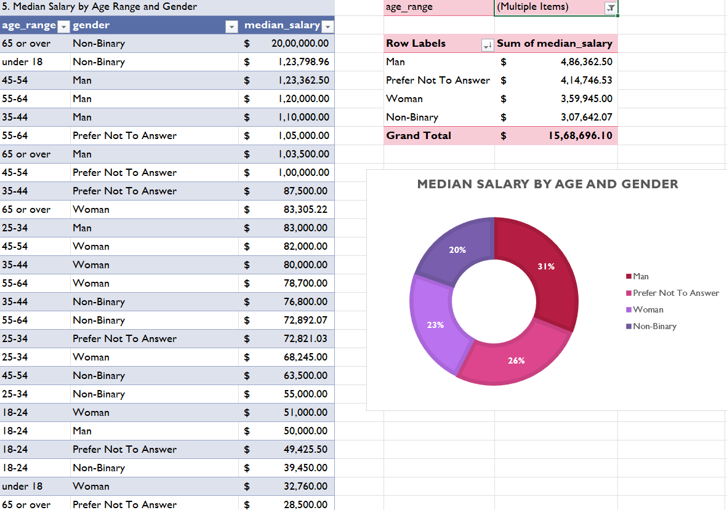

**6. Job Titles with the Highest Salary in Each Country**

**Insights**

* Highest Paying Job: "Inside Sales Manager" in the USA has the highest salary ($5,004,044).
* Global Salary Trends: Salaries vary significantly across countries, with roles like Product Manager and Cyber Security Management being among the top-paying.
* Regional Specialization: Different industries dominate different countries (e.g., IT Security in Australia, Research in India).
* Total Salary Impact: The sum of the highest salaries across all countries amounts to approximately $20.89 million.

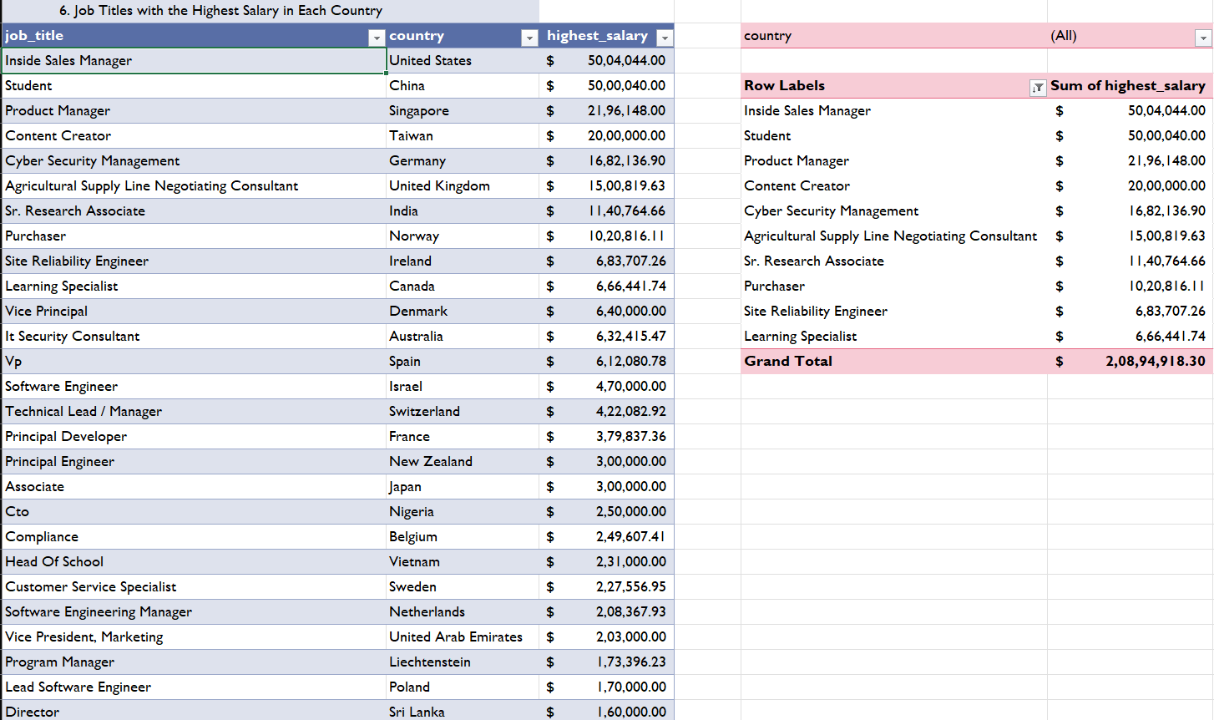

**7. Average Salary by City and Industry**

**Insights**

* Sales roles in Pinebrook and Banking & Finance in Hong Kong have the highest salaries (~$5M).
* Tech roles (Computing, Social Networks) dominate in cities like Network, Milwaukee, and Germany.
* Oil & Gas in Oslo and Agriculture in London also show high salaries.
* Some industries, like Education and Nonprofits, have relatively lower average salaries.
* 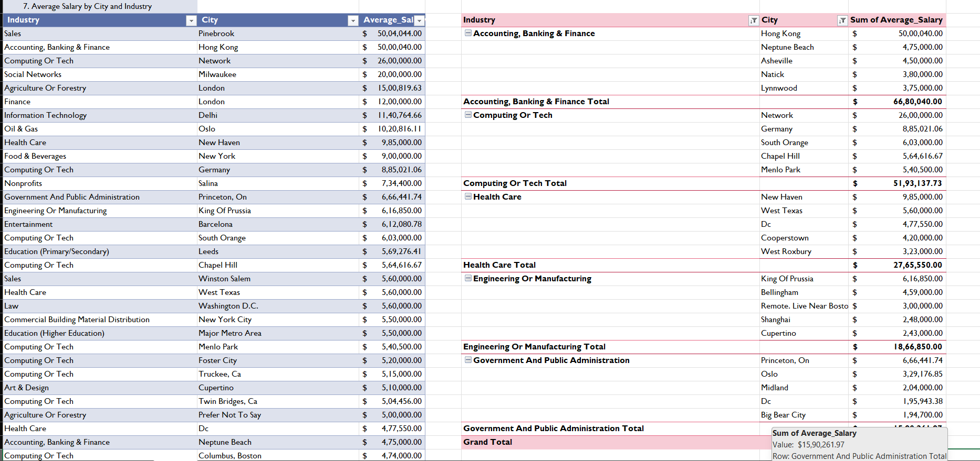The pivot table shows total salaries per industry, with Finance, Tech, and Healthcare being the highest-paying sectors overall.

**8. Percentage of Employees with Additional Monetary Compensation by Gender**

**Insights**

* This query tells us the gender distribution of employees who received additional monetary compensation.
* If one gender has a significantly higher percentage, it suggests they receive additional compensation more frequently.
* However, it does not give information about the percentage of employees within each gender who received additional compensation.
* If one gender has a significantly higher percentage, it might indicate a bias in compensation distribution.
* The total sum of percentages from this query does not necessarily equal 100%, as it is calculated within each gender category.

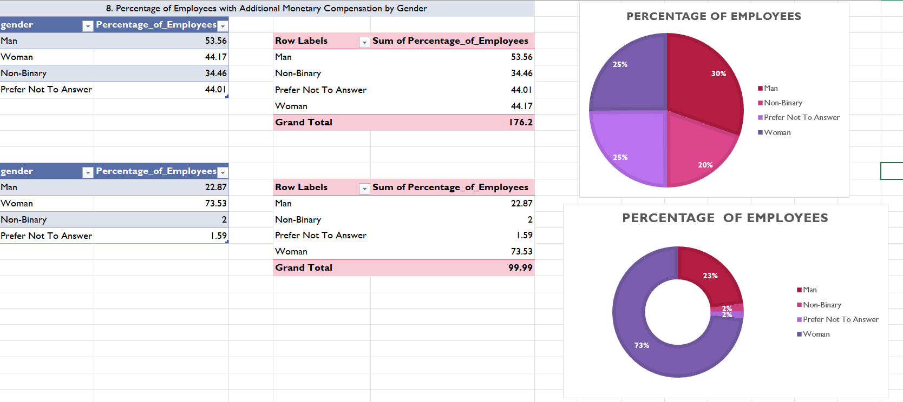

**9. Total Compensation by Job Title and Years of Experience**

**Insights**

* Software Engineers have the highest total salary compensation, followed by Senior Software Engineers and Directors.
* Higher experience does not always mean the highest total salary. For example, Software Engineers with 2-4 years of experience have a higher total salary than some roles with more experience.
* Leadership roles like Directors and Vice Presidents earn significant compensation, but some engineering roles also compete closely in total earnings.
* Project Managers, Product Managers, and Engineering Managers also receive high total

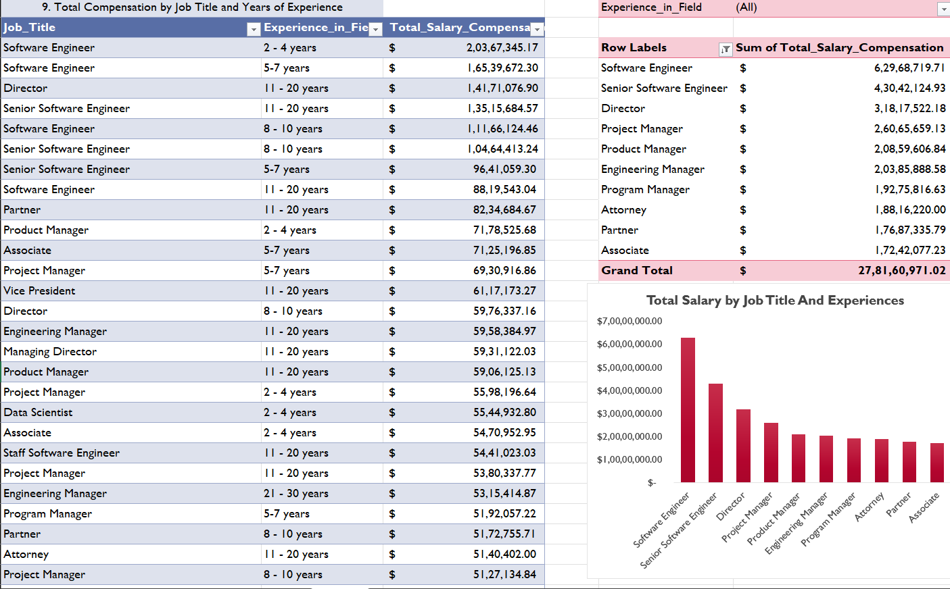

**10. Average Salary by Industry, Gender, and Education Level**

**Insights**

* Highest Salaries
  + Social Networks (Non-Binary, PhD) – $2,000,000 has the highest average salary.
  + Accounting & Finance (Non-Binary, High School) – $1,704,566 also has a high salary, indicating experience or other factors matter.
  + Finance (Men, Master’s Degree) – $1,200,000 shows finance is a high-paying field.
  + Information Technology (Women, PhD) – $1,140,764 confirms PhD holders earn more in IT.
* Industry Trends
  + Computing/Tech, Finance, and Accounting have the highest total average salaries.
  + Healthcare, Biotechnology, and Energy also have strong salary figures.
  + Sales, Consulting, and Utilities follow closely in salary distribution.
* Education Matters
  + PhD holders tend to have higher salaries across different industries.
  + However, some high salaries exist even for those with lower education levels, suggesting experience and skills also play a role.
* Gender-Based Trends
  + Women in Information Technology (PhD) earn over $1.1M, showing high potential for women in tech.
  + Non-Binary individuals have high salaries in Social Networks and Finance.
  + 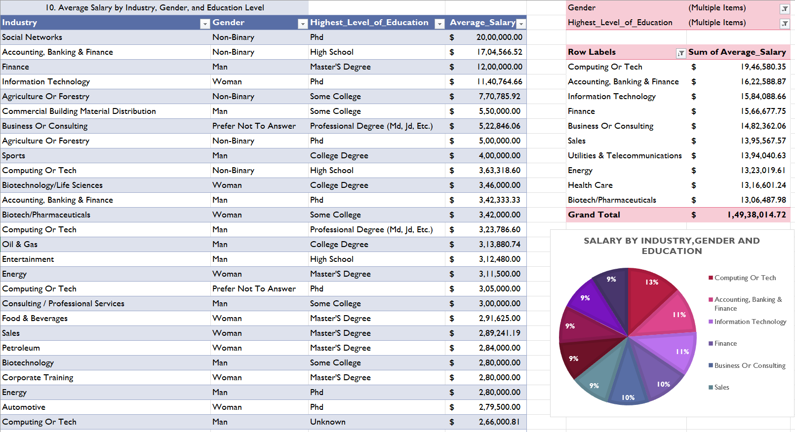Men in Finance and Consulting earn significantly, confirming male dominance in high-paying corporate roles.

**12. Dashboard**

This Dashboard presents an overview of key insights from the Salary Trends & Analysis Dashboard, highlighting salary distribution across industries, job roles, experience levels, and demographics.

**Overall Salary Trends**  
The average salary across industries is $99,839.65, providing a benchmark for salary comparisons. The dataset covers 27,814 industries, offering a broad view of salary variations. The highest-paying industry is Computing or Tech, indicating that IT and technology-related fields offer the most lucrative opportunities.

**Salary Trends by Job Titles**  
Top-paying job titles include Owner & CEO, Lead, Sales Manager, Cybersecurity Expert, and Physician. These roles command high salaries due to their expertise, experience, and responsibility. However, in terms of employee count, Software Engineers, Project Managers, Senior Software Engineers, and Directors dominate. Although these roles are more common, leadership and specialized roles like CEO and Cybersecurity Expert continue to earn the highest.

**Salary Analysis by Industry**  
The top industries by salary distribution include:

* **Social Networks** – contributing 55% of total salaries.
* **Commercial Building Material Distribution** – contributing 15%.
* **Sports, Utilities, and Petroleum** – with smaller percentage shares.  
  Social Networks dominate the salary market, likely due to the high demand and growth in tech-driven sectors. In contrast, traditional industries like utilities and petroleum offer lower salary shares, reflecting a shift in high-paying jobs toward technology.

**Salary Distribution by Experience**  
Salary trends increase with experience, peaking at 41+ years. However, salaries decline after 11-20 years, possibly due to career shifts or stagnation. New professionals with 1-4 years of experience earn significantly less, emphasizing the importance of experience in salary growth. Employees may be transitioning into leadership roles after 20 years, which can impact base salaries.

**Salary Trends by Gender & Education**  
The dashboard allows salary comparison by gender, enabling potential analysis of pay gaps. A comparison across genders—Men, Women, Non-Binary, and Prefer Not to Answer—could reveal disparities.

Education also plays a key role in salary trends. A majority of employees hold college degrees (55%), while Master’s and PhD holders (11% each) earn higher salaries. High school graduates and those with “Unknown” education levels have the lowest salary shares. Higher education correlates positively with higher earnings, and a detailed comparison between Master’s and PhD holders could provide further insights on the impact of advanced education on salary growth.

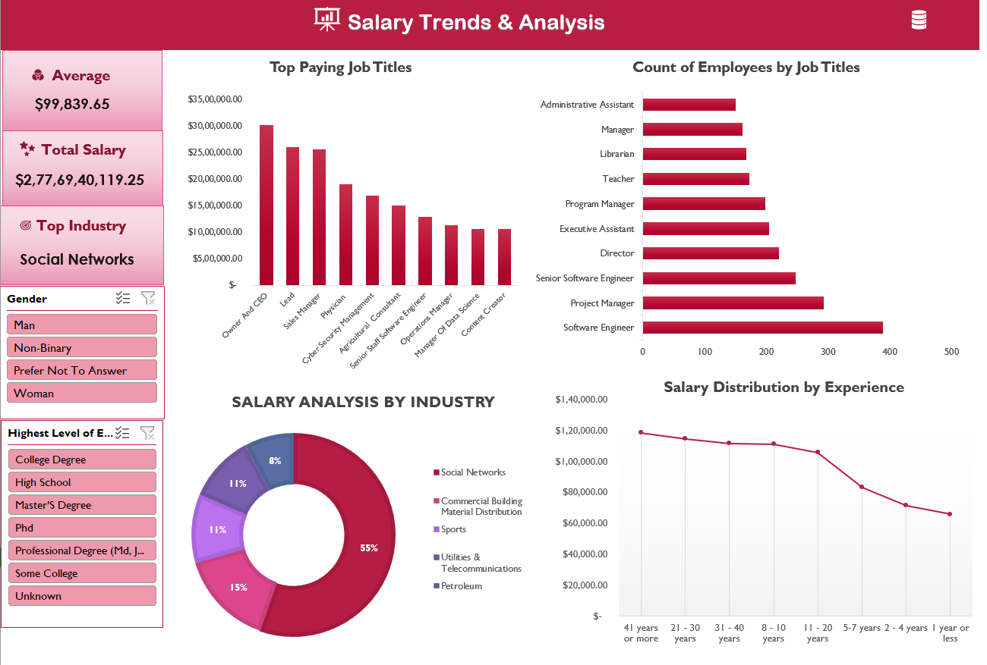

**Conclusion**

The Salary Trends & Analysis Dashboard highlights several critical insights that provide a deeper understanding of salary distribution across industries, job roles, experience levels, and demographics.

1. **Tech Dominates Salary Growth:**  
   The Computing and Tech industry emerges as the highest-paying sector. This trend underscores the increasing demand for technology-related expertise and the lucrative nature of IT and Tech careers.
2. **High-Paying Roles Are Specialized:**  
   Top-paying job titles such as **Owner & CEO, Lead, Sales Manager, Cybersecurity Expert, and Physician** command higher salaries due to their specialized nature, leadership responsibilities, and the expertise required. These roles often offer greater financial rewards compared to more common positions.
3. **Experience Drives Salary Progression:**  
   Salary progression is closely tied to experience, with notable growth occurring between **21-40 years**. However, a decline is observed after **41+ years**, possibly indicating career shifts, transitions into leadership roles, or movement toward non-salary-based compensation.
4. **Education Enhances Earning Potential:**  
   Employees with **Master’s and PhD degrees** earn higher salaries compared to those with only college degrees or lower educational qualifications. This reinforces the positive correlation between advanced education and long-term earning potential.
5. **Potential Gender Disparities Exist:**  
   The dashboard offers the ability to filter salary data by gender, which provides an opportunity to analyze and address potential pay gaps. A thorough review of gender-based salary differences may reveal areas that require attention to ensure fair compensation.

**Key Takeaways**

* **Tech Sector Leads in Pay:**  
  The IT and Tech industry consistently offers the highest salaries, making it a lucrative field for professionals with relevant expertise.
* **Specialized Roles Offer Higher Rewards:**  
  Leadership and niche positions, such as CEOs and Cybersecurity Experts, attract higher salaries due to their complexity and impact.
* **Experience is Crucial for Salary Growth:**  
  Higher salaries correlate with increasing years of experience, although salary growth tends to plateau or decline after 41 years.
* **Higher Education Pays Off:**  
  Employees with advanced degrees benefit from significantly higher earning potential compared to their less-educated counterparts.
* **Gender Pay Gap Awareness is Essential:**  
  Gender-based salary comparisons can help identify pay gaps and promote fair compensation across all demographic groups.

**Date :** 17-03-2025 **By,**

**Yahavarshini E**